
Viewed by:
Philippe POHER
Tel.: +33 (0)2 99 27 92 92
E-mail: philippe.poher@iwedia.com

Written by:
Philippe POHER
Tel.: +33 (0)2 99 27 92 92
E-mail: philippe.poher@iwedia.com
IWEDIA

TDAL_FP Technical Specifications

V2.1

Approved by:
Thierry GARNIER
Tel.: +33 (0)2 99 27 92 92
E-mail: thierry.garnier@iwedia.com

SUMMARY
1 Reference documents 3
2 Documentation History 4
3 Introduction 5
4 Module Overview and Architecture 6
4.1 Definitions, Acronyms and Abbreviations 6
4.2 General Description 7
4.3 Architecture 7
4.4 TDAL_FP API Description 8
4.4.1 Generic Interface 8
5 TDAL_FP API Specification 9
5.1 Type Specifications 9
5.1.1 Generic 9
5.2 TDAL_FP API Usage 10
5.2.1 Event notification, and information display 10
5.3 TDAL_FP Macro/Define/Enum/Typedef/Structure Definitions 11
5.3.1 Define Definitions 11
5.3.1.1 kTDAL_FP_NO_ID 11
5.3.1.2 kTDAL_FP_NO_KEY 11
5.3.1.3 kTDAL_FP_NB_DIGIT 11
5.3.1.4 FP Key definition 11
5.3.1.5 FP String definition 12
5.3.2 Enum Definitions 12
5.3.2.1 tTDAL_FP_ErrorCode 12
5.3.2.2 tTDAL_FP_KeyStatus 12
5.3.2.3 tTDAL_FP_Info 13
5.3.3 Typedef Definitions 13
5.3.3.1 tTDAL_FP_ClientId 13
5.3.3.2 tTDAL_FP_KeyCode 13
5.3.3.3 tTDAL_FP_CallbackFct 14
5.3.4 Structure Definitions 15
5.4 TDAL_FP API Functions 16
5.4.1 Generic Interface API 16
5.4.1.1 TDAL_FP_Init(-) 16
5.4.1.2 TDAL_FP_Terminate(-) 17
5.4.1.3 TDAL_FP_Register(-) 18
5.4.1.4 TDAL_FP_UnRegister(-) 19
5.4.1.5 TDAL_FP_SetInfo(-) 20
6 TDAL_FP External Dependencies 21
6.1.1.1 tTDAL_FP_CallbackFct 21

Reference documents
The following documents were used to write this specification:

Document | Version | Title

Documentation History

History
Vers. | Date | Nature
2.0 | 17/01/2008 | PPO: First version of TDAL_FP
2.1 | 7/10/2008 | eTDAL_FP_INFO_ERROR added

Introduction
The purpose of this document is to specify the interface and to describe the internal design of the Thin Driver Adaptation Layer for Front Panel [TDAL_FP]. The aim of this module is to provide a complete interface between middlewares and the front panel stage low level driver of a set-top-box.

Module Overview and Architecture

Definitions, Acronyms and Abbreviations
CHAL | Comedia hardware Adaptation Layer, composed of TDALs driver, TKEL and TBOX module
TDAL | Thin Driver Adaptation Layer
TKEL | Thin Kernel Encapsulation Layer
TBOX | Tool Box

General Description
The main job of the TDAL_FP is to get the front panel events from button inserted in front panel and display according to product capabilities information given by the client.

The information display may be done by single led management, 7 segments display, …

The TDAL_FP is in charge to personalize and choose how the information will be presented to the end-user.
The TDAL_FP may interpret the following state of a button:

- PRESSED
- RELEASED
- HELD DOWN

Architecture
The figure below shows the relation between the client module and the low level drivers:
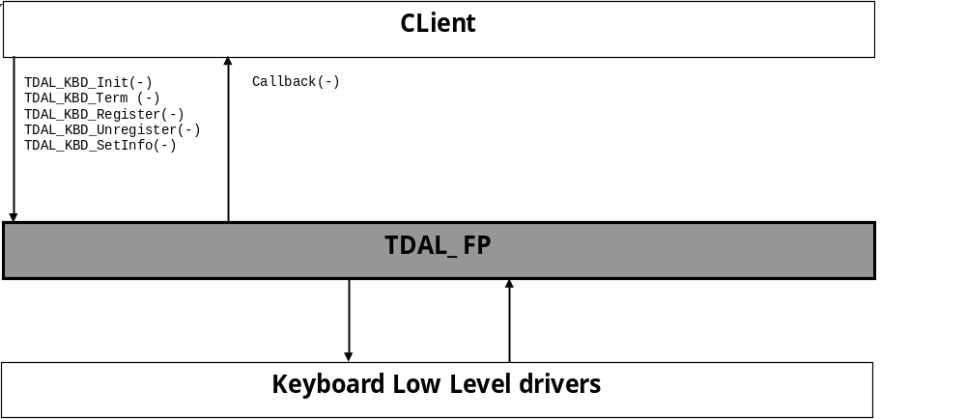

TDAL_FP API Description

Generic Interface
The generic interface allows clients to control the TDAL_FP module.
This interface is used with the following functions:
- TDAL_FP_Init(-) in order to initialize the TDAL_FP module.
- TDAL_FP_Term(-) in order to terminate the TDAL_FP module.
- TDAL_FP_Register(-) in order to register one client to TDAL_FP
- TDAL_FP_Unregister(-) in order to unregister one client to TDAL_FP
- TDAL_FP_SetInfo(-) in order to display information to the end-user.

TDAL_FP API Specification

Type Specifications

Generic
tTDAL_FP_ErrorCode is the error code return by TDAL_FP function.
tTDAL_FP_ClientId is the type which defines the value used to identify a client of TDAL_FP.
tTDAL_FP_KeyStatus is an enumeration of different state of the button to define the event happens.
tTDAL_FP_CallbackFct is the callback to implement by the client to receive event notification.
tTDAL_FP_Info is the information type sent by the client
tTDAL_FP_TimeFormat is the format of time info sent by the client
tTDAL_FP_Time is the time info sent by the client

TDAL_FP API Usage

Event notification, and information display

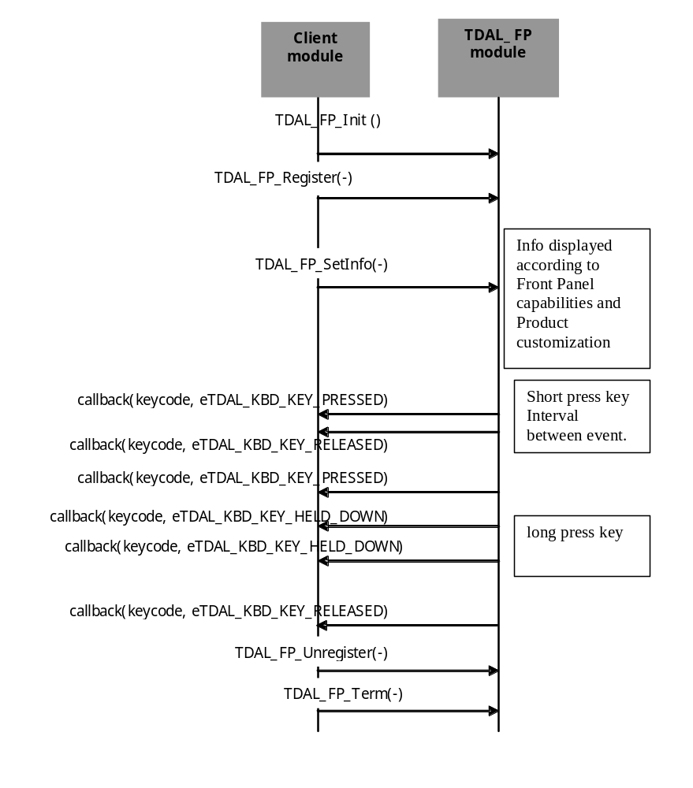

TDAL_FP Macro/Define/Enum/Typedef/Structure Definitions

Define Definitions

kTDAL_FP_NO_ID
This constant is used to define the invalid client Id value
#define kTDAL_FP_NO_ID -1

kTDAL_FP_NO_KEY
This value is used to define invalid Key value.
#define kTDAL_FP_NO_KEY 0

kTDAL_FP_NB_DIGIT
This value is used to define maximum nb digits to manage.
/* number to digit to manage */
#define kTDAL_FP_NB_DIGIT 4

FP Key definition
This constant is used to define the common key found on Front panel.

These defines are done to inform of the client that two keys may be pressed/released at the same time for a specific action.

#define kTDAL_FP_NO_KEY 0x00
#define kTDAL_FP_POWER_KEY 0x01
#define kTDAL_FP_SELECT_KEY 0x02
#define kTDAL_FP_MENU_KEY 0x04
#define kTDAL_FP_RIGHT_ARROW_KEY 0x08
#define kTDAL_FP_LEFT_ARROW_KEY 0x10
#define kTDAL_FP_UP_ARROW_KEY 0x20
#define kTDAL_FP_DOWN_ARROW_KEY 0x40
#define kTDAL_FP_EXIT_KEY 0x80
#define kTDAL_FP_PROGRAM_NEXT_KEY 0x0f
#define kTDAL_FP_PROGRAM_PREV_KEY 0xf0

FP String definition
This constant is used to define the constant string definition.
/* to inform end-user current action is success */
#define kTDAL_FP_OK_STRING "OK"
/* to inform end-user current action is a fail */
#define kTDAL_FP_NOK_STRING "NOK"
/* to inform end-user that a stream is played */
#define kTDAL_FP_STRING_PVR_PLAY "PLAY"

Enum Definitions

tTDAL_FP_ErrorCode
An enumeration of the different possible error value handled by TDAL_FP.
typedef enum {
eTDAL_FP_NO_ERROR,
eTDAL_FP_ERROR
}tTDAL_FP_ErrorCode;

tTDAL_FP_KeyStatus
An enumeration of the different possible status of button event.

typedef enum {
eTDAL_FP_KEY_PRESSED,
eTDAL_FP_KEY_RELEASED,
eTDAL_FP_KEY_HELD_DOWN
}tTDAL_FP_KeyStatus;

tTDAL_FP_Info
An enumeration of the different possible time format.

eTDAL_FP_INFO_BOOTING,
eTDAL_FP_INFO_ON,
eTDAL_FP_INFO_OFF,
eTDAL_FP_INFO_RECORD,
eTDAL_FP_INFO_FLASH_ERASE,
eTDAL_FP_INFO_FLASH_RW,
eTDAL_FP_INFO_RCVDATA,
eTDAL_FP_INFO_RCVINFRARED,
eTDAL_FP_INFO_SCANNING,
eTDAL_FP_INFO_HOUR,
eTDAL_FP_INFO_MIN,
eTDAL_FP_INFO_STRING,
eTDAL_FP_INFO_VIDEO_START,
eTDAL_FP_INFO_SHOW_MENU,
eTDAL_FP_INFO_FE_LOCK,
eTDAL_FP_INFO_DOWNLOAD,
eTDAL_FP_INFO_ERROR,
eTDAL_FP_INFO_CHANNELNUMBER,
eTDAL_FP_INFO_PVR

Typedef Definitions

tTDAL_FP_ClientId
This type enables to define client identifier type.
typedef int16_t tTDAL_FP_ClientId;

tTDAL_FP_KeyCode
This type enables to define key code value of front panel button protocol.
typedef uint32_t tTDAL_FP_KeyCode;

tTDAL_FP_CallbackFct
This typedef defines the callback type registered by the client to receive TDAL_FP events
typedef void (*tTDAL_FP_CallbackFct) (
tTDAL_FP_KeyCode KeyCode,
tTDAL_FP_KeyStatus KeyStatus
);

Parameters:
Parameter | Type | Dir | Description
KeyCode | tTDAL_FP_KeyCode | In | Keycode event received
KeyStatus | tTDAL_FP_KeyStatus | In | Type of action done on remote control button

Structure Definitions
None

TDAL_FP API Functions

Generic Interface API

TDAL_FP_Init(-)
Prototype:
tTDAL_FP_Error TDAL_FP_Init (void);
Description:
This function initialises the TDAL_FP module.
Return value:
It returns eTDAL_FP_NO_ERROR if initialization succeed.
It could eTDAL_FP_ERROR otherwise.
Parameters:
None.
Comments:
This function must be called before any other functions of the TDAL_FP API.
See Also:
TDAL_FP_Terminate(-).

TDAL_FP_Terminate(-)
Prototype:
tTDAL_FP_Error TDAL_FP_Terminate (void);
Description:
This function terminates the TDAL_FP module.
Return value:
It returns eTDAL_FP_NO_ERROR if termination succeed.
It could eTDAL_FP_ERROR otherwise.
Parameters:
None.
Comments:
Any function of TDAL_FP API should not be called after TDAL_FP_Terminate(-) call.
See Also:
TDAL_FP_Init(-).

TDAL_FP_Register(-)
Prototype:
tTDAL_FP_ClientId TDAL_FP_Register(
tTDAL_FP_CallbackFct callback /* I: Function called upon key events */
);
Description:
This function enables a client to register itself to TDAL_FP to receive remote font panel buttons events associated to the end-user action

Return value:
It returns the client Id if register succeeds. Else returns kTDAL_FP_NO_ID
Parameters:
Parameter | Type | Dir | Description
callback | tTDAL_FP_CallbackFct | In | Callback to register to client.
Comments:
This function can be called at any time the TDAL_FP has been initialised with TDAL_FP_Init(-) but not after the termination with TDAL_FP_Terminate(-).
See Also:
tTDAL_FP_CallbackFct

TDAL_FP_UnRegister(-)
Prototype:
tTDAL_FP_ErrorCode TDAL_FP_UnRegister(
tTDAL_FP_ClientId clientId /* I: Id of the client to unregister */
);
Description:
This function unregisters a client from TDAL_FP
Return value:
It returns eTDAL_FP_NO_ERROR if termination succeed.
It could eTDAL_FP_ERROR otherwise.
Parameters:
Parameter | Type | Dir | Description
clientId | tTDAL_FP_ClientId clientId | In | Client identifier
Comments:
This function can be called at any time the TDAL_FP has been initialised with TDAL_FP_Init(-) but not after the termination with TDAL_FP_Terminate(-).
See Also:
tTDAL_FP_ClientId

TDAL_FP_SetInfo(-)
Prototype:
tTDAL_FP_ErrorCode TDAL_FP_SetInfo(
tTDAL_FP_Info eInfo,
const void* param
);
Description:
This function enables the client to request the display of an information.
Return value:
It returns eTDAL_FP_NO_ERROR if termination succeed.
It could eTDAL_FP_ERROR otherwise.
Parameters:
Parameter | Type | Dir | Description
eInfo | tTDAL_FP_Info | In | Information to display
param | const void* | In | String which contains info  Either kTDAL_FP_OK_STRING, kTDAL_FP_NOK_STRING,  kTDAL_FP_STRING_PVR_PLAY or a ascii string defined by the client only
Comments:
This function can be called at any time the TDAL_FP has been initialised with TDAL_FP_Init(-) but not after the termination with TDAL_FP_Terminate(-).
See Also:
tTDAL_FP_Info
FP String definition

TDAL_FP External Dependencies

tTDAL_FP_CallbackFct
This type defines the call-back prototype that a client must give to TDAL_FP to receive events.
Prototype:
typedef void (*tTDAL_FP_CallbackFct) (
tTDAL_FP_KeyCode KeyCode,
tTDAL_FP_KeyStatus KeyStatus
);

Return value:
None.
Parameters:
Parameter | Type | Dir | Description
KeyCode | tTDAL_FP_KeyCode | In | Key code of the button selected
KeyStatus | tTDAL_FP_KeyStatus | In | Status of the button managed
Comments:
None.
See Also:
tTDAL_FP_CallbackFct
TDAL_FP_Register(-)

tTDAL_FP_KeyCode

